 | IT Express

Template for Course Preparation

Title: Computer Based Marketing and Communication

Course material

© IT EXPRESS partnership, 2012
COURSE IN VIRTUAL LEARNING ENVIRONMENT
(Address and logins to the course):__________________________

Institution: Kaunas University of Technology

Authors:
Danguole Rutkauskiene,
Daina Gudoniene,
Egidijus Asipauskas

Content
CALENDAR/CONTENT 5
COURSE CARD 7
LEARNING GOALS PER LEARNING UNIT 9
Enterprise social networking 9
INTRODUCTION 12
Learning unit 1. Enterprise social networking 13
1.1. ICT based business possibilities 13
1.1.1. ICT based solutions 13
1.1.2. Blogging at small and medium enterprises 13
1.1.3. Wikis for small and medium enterprises 14
1.1.4. Internal small and medium enterprises communities platforms 14
1.1.5. Social software functions 14
1.1.6. Specific uses of computer based marketing 15
1.2. How to Improve Business Communication Skills 16
1.3. How to Solve Business Communication Problems 17
1.4. How to start an online business 17
1.4.1. Choose Your Focus 17
1.4.2. Create an Online Presence 18
1.4.3. Finance your Endeavour 19
1.4.4. Miscellaneous 19
1.5. Growth of social software for communication 20
Learning unit 2. Web 2.0 tools for business management at small and medium enterprises 21
2.1. Blogs 22
2.2. Wiki 24
2.3. Google mail 26
2.4. Skype 29
2.5. RSS 30
2.6. Twitter 32
Learning unit 3. Computer based marketing solutions and communication in real time 34
3.1. Camtasia 35
3.2. Adobe Connect 37
3.3. YouTube 39
Learning unit 4. Research tools for computer based marketing and data analysis 42
4.1. SurveyMonkey 43
4.2.LimeSurvey 44
4.3. Google form/spreadsheet 45
Learning unit 5. E-facilities for online marketing solutions 47
5.1. E-bookstores 47
5.2. E-banking 47
5.3. E-shops 48
5.4. E-tickets 48
5.6. Social services 48
Learning unit 6. E-commerce as a possibility for business introduction and implementation 48
Learning unit 7. E-marketing for small and medium enterprises 50
7.1. What is Marketing? 50
7.2. Why Marketing is so important? 50
7.3. Business Marketing Plan 51
7.4. Difference in traditional and network marketing 52
Self assessment tests 54

CALENDAR/CONTENT
Note: F2F PW # means face to face practical works #
Unit/ Week # | Mode of educational  activity |  | Title/Brief description | Notes  (proposal of developer)
Introduction
Course glossary: basic concepts and terminology used
Learning unit 1 |  |  | Enterprise social networking | 6h
1 | Lecture 1 |  | 1.1. ICT based business possibilities  1.2. How to Improve Business Communication Skills  1.3. How to Solve Business Communication Problems  1.4. How to start online business  1.5. Growth of social software for communication
1 | Lecture 2
2 | Lecture 3
2 | F2F PW 1 + homework
2 | Assessment |  | Self assessment
Learning unit 2 |  |  | Web 2.0 tools for business management at small and medium enterprises | 8h
3 | Lecture 4 |  | 2.1. Blogs  2.2. Wiki  2.3. Google mail  2.4. Skype  2.5. RSS  2.6. Twitter
3 | Lecture 5
4 | Lecture 6
4 | F2F PW 2 |  | -
4 | Assessment |  | Self assessment
Learning unit 3 |  |  | Computer based marketing solutions and communication in real time |  | 6h
5 |  | Lecture 7 | 3.1. Camtasia
 |  | Lecture 8 | 3.2. Adobe Connect
6 |  | Lecture 9 | 3.3. YouTube
 |  | On-line seminar 3 | -
 |  | Assessment | Self assessment
Learning unit 4 |  |  | Research tools for computer based marketing and data analysis |  | 6h
7 |  | Lecture 10 | 4.1. SurveyMonkey  4.2. LimeSurvey  4.3. Google form/spreadsheet
 |  | Lecture 11
8 |  | F2F PW 4 + homework
 |  | F2F PW 5 + homework
 |  | Assessment | Self assessment
Learning unit 5 |  |  | E-facilities for online marketing solutions |  | 4h
9 |  | Lecture 12 | 5.1. E-bookstores  5.2. E-banking  5.3. E-shops  5.4. E-libraries  5.5. E-tickets  5.6. Social services
 |  | Lecture 13
 |  | F2F PW 6 + homework
10 |  | Lecture 14
 |  | F2F PW 7 + homework | -
 |  | Assessment | Self assessment

Learning unit 6 |  | E-commerce as a possibility for business introduction and implementation | 2h
11 | Lecture 15
11 | Lecture 16
12 | Lecture 17
12 | F2F PW 8 + homework | -
12 | Assessment | Self assessment

Learning unit 7 |  | E-marketing for small and medium enterprises | 3h
11 | Lecture 15 | 7.1. What is Marketing?  7.2. Why Marketing is so important?  7.3. Business Marketing Plan  7.4. Difference in traditional and network marketing
11 | Lecture 16
12 | Lecture 17
12 | F2F PW 8 + homework | -
12 | Assessment | Self assessment

For final work, please choose one of the learned tools and write an essay, how that tool can help and improve your business (~1000 words). (5 hours)

COURSE CARD
Title | For filling | Comments
Title of the course | Computer Based Marketing and Communication
Institution | KTU
Authors: | Danguole Rutkauskiene,  Daina Gudoniene,  Egidijus Asipauskas
Course for (target group) | Participants of SME’s
Forms of learning (distance learning, or face to face or blended learning) | Distance learning / blended learning
Learning Units | - Enterprise social networking  - Web 2.0 tools for business management at small and medium enterprises  - Computer based marketing solutions and communication in real time  - Research tools for computer based marketing and data analysis  - E-facilities for online marketing solutions  - E-commerce as a possibility for business introduction and implementation  - E-marketing for small and medium enterprises
Course goals | The aim of the course is to present open online solutions for implementing Computer Based Marketing and Communication.
Languages (EN…) | EN/LT
Address of the course (WWW) | -
Preparation for courses delivery (basic knowledge’s need to have students) | Computer and computer literacy skills
Technical requirements for study process | Computer or other device with internet access, headphones, microphone, Internet
Course duration (hours, months or credits) | 40 hours
Tasks for students | Final work
Self-evaluation tests/questions | Self-assessment
Examination forms | Not applicable

LEARNING GOALS PER LEARNING UNIT

Learning unit No. | Learning unit title | Annotation of Learning unit | Title of lecture or learning activity | Learning goals of lecture
Learning unit 1 | Enterprise social networking | 1.1. ICT based business possibilities  1.2. How to Improve Business Communication Skills  1.3. How to Solve Business Communication Problems  1.4. How to start online business  1.5. Growth of social software for communication | - | The aim of the unit is to present social software Enterprise 2.0 that helps to employees; customers and suppliers collaborate, share, and manage information using different Web 2.0 technologies and resources.
Learning unit 2 | Web 2.0 tools for business management at small and medium enterprises | 2.1. Blogs  2.2. Wiki  2.3. Google mail  2.4. Skype  2.4. RSS  2.5. Twitter | - | The aim of the unit is to present the new open technologies and applications as Web 2.0 plays a central part in the functioning and delivery of marketing and entrepreneurship.
Learning unit 3 | Computer based marketing solutions and communication in real time | 3.1. Camtasia  3.2. Adobe connect  3.3. YouTube | - | The aim of the unit is to overview Real-time communication (RTC) tools in which all users can exchange information instantly or with negligible latency and use those as marketing solutions for their business.
Learning unit 4 | Research tools for computer based marketing and data analysis | 4.1. SurveyMonkey  4.2. Limesurvey  4.3. Google form / spreadsheet | - | The aim of the unit is to overview some research tools, which can be used by SME’s for marketing, data analysis and improvement of marketing products and services.
Learning unit 5 | E-facilities for online marketing solutions | 5.1. E-bookstores  5.2. E-banking  5.3. E-shops  5.4. E-libraries  5.5. E-tickets  5.6. Social services | - | The aim of the unit is to present the most comprehensive range of fully accountable online marketing solutions available.
Learning unit 6 | E-commerce as a possibility for business introduction and implementation |  | - | The aim of the unit is to introduce E-commerce as a possibility for business and implementation.
Learning unit 7 | E-marketing for small and medium enterprises | 7.1. What Is Marketing?  7.2. Why Marketing is so important?  7.3. Business Marketing Plan  7.4. Difference in traditional and network marketing | - | The aims of this unit are to present what marketing is in general, both traditional and internet, and what is needed to bring business to success.

INTRODUCTION

The aim of the course is to present open online solutions for implementing Computer Based Marketing and Communication.
There is included information about the tools and resources for arrangement of business at small and medium enterprises (SME). They help to managing, enhancing and growing business by offering best practices and solutions within technology and innovation, finance, law, public policy, marketing, resources, analytics, strategic planning and work.
Nowadays ICT based solutions is a key to cost-effective operations, help to get the word about you and your business. When everyting is going online, sustainable enterprises should innovate, adopt appropriate environmental friendly technologies, develop skills and human resources, and enhance productivity to remain competitive in traditional and Internet markets. Having that in mind, many tools have been designed to help SME‘s take advantage of ICT in specific areas. In this course there will be overviewed some of those points, wich help to stimulate growth, development and many more.

Learning unit 1. Enterprise social networking
Social software is well known as component of Enterprise 2.0, which comprises social software as used in business/commercial contexts and supports users to manage different information and solutions, includes social and networked modifications to corporate intranets and other classic software platforms that could be used by small and medium as well as large enterprises to organize their communication. In contrast to traditional enterprise software, which imposes structure prior to use, enterprise social software tends to encourage use prior to providing structure.
There is used term of Enterprise Web 2.0 which sometimes refers to the introduction and implementation within an enterprise of Web 2.0 technologies and applications, including rich Internet applications, providing software as a service, and using the web as a general platform for computer based communication and collaboration.

1.1. ICT based business possibilities

1.1.1. ICT based solutions
The capability of enterprises location provides corporations with the ability to solve business problems that are difficult to articulate or communicate explicitly and that involve highly skilled people. Mobile people are looking for searches and are increasingly seen as integral components of a support environment that encourages unplanned collaboration and informal interactions such as effective ways to solve business problems. Expertise location is very important and it increases productivity and organizational success as well as mobile location of enterprises human resources in globally dispersed and increasingly virtual organizations. Preparation and publishing of employee profiles and searches against those profiles are increasingly seen by strategists as integral components of a business process that encourages unplanned collaboration and informal interactions as effective ways to solve business problems. Social network tools and environments help managers or etc. administrative staff of SME to find or select the right person or group for the appropriate task.

1.1.2. Blogging at small and medium enterprises
Like personal blogs, corporate blogs use blogging technology information-management forums, i.e. Google Inc. and Facebook Inc., pioneered this practice within SME. The blogs are usually becoming a part of the standard selection of necessary corporate communication tools and the emerging portfolio of social-media tools or environments. Different features such as tags and ratings help corporate employees, to find content and to make judgments about policies or procedures.

1.1.3. Wikis for small and medium enterprises
Corporate wikis provide an easy-to-use environment for subject-matter experts and help to publish their interpretation on any subject. A corporate wiki can capture corporate acronyms. Large corporations create a roll-up wiki so that individual divisions have the flexibility to add items to their wiki and make a decision on which items should roll up to the corporate level. Wikis, like blogs, provide platforms for collaboration and communication.

1.1.4. Internal small and medium enterprises communities platforms
Usually the internal SME platforms provide an environment to corporate employees to create a virtual forum to share their opinions, knowledge and subject matter expertise on topics of interest. Small and medium enterprise community’s platform centers on a particular topic of interest. General the community participates in an unstructured exchange of ideas, which could mature given significant interest from the community.

1.1.5. Social software functions
Social software functions are acceptable for small and medium enterprises to act as business management, i.e. search: allowing users to search for other users or content; links: grouping similar users or content together; authoring: including blogs and wikis; tags: allowing users to tag content; extensions: recommendations of users; or content based on profile; signals: allowing people to subscribe to users or content with RSS feeds.
Other functions related to the open online content are presented online with business information:
Free form function: no barriers to authorship (meaning free from a learning curve or from restrictions); network-oriented function, requiring web-addressable content in all cases; social function: stressing transparency (to access), diversity (in content and community members) and openness (to structure); emergence function: requiring the provision of approaches that detect and leverage the collective wisdom of the community.
Specific social software tools for enterprises could be used for computer based marketing: wikis; micro blogging; blogs/weblogs for storytelling and sharing personal knowledge and experiences; enterprise social bookmarking for tagging and building organizational knowledge; RSS and activity streams for signalling; collaborative planning software for peer-based project planning and management; ideas banks for ideation (idea generation); social networking tools; mashups for visualization; prediction markets for forecasting and identifying risks; social profile for displaying user's social graph and activity stream (micro-blog). Profiles may optionally display user's interests and expertise for expertise search; web content management system; instant messaging; file sharing.
Social networking possibilities can help small and medium enterprises capture unstructured information. The challenge then becomes how to distil meaningful, re-usable knowledge from other content also captured in tools such as blogs, online communities, and wikis. In 2008, companies that provide enterprise social software started introducing profile pages to their products, to integrate the functionality of public online communities within the enterprise. This enables users to find others with the knowledge or necessary information about business. Large organizations find this especially useful.

1.1.6. Specific uses of computer based marketing
Web 2.0 technologies such as Blogs and wikis are functioning as collaboration tools, and uses mainly in sharing information about business and products/facilities introduction. However, it is possible to start converting its official documentation to wikis, because this enables that SME to make documentation updates available in real time and users are able to contribute to the documentation.
These applications can bring added value to SME’s as it facilitates user ergonomics: navigation more suited to the user, which will save time, in all media focusing inside. Some RSS readers can operate in offline RSS feeds to keep employees informed of events: the contribution of the RSS is more customizable, which allows information to focus on individual interests and activities, and mode, a wiki for the company documentation: what a service calls to reach such an entity, which is the contact person for doing something, what is this abbreviation to clean work areas, etc. The collaborative operation as a whole removes some traditional boundaries of hierarchy and organization, increased interaction with customers, simplified integration with partners.
Business processes often rely on access to “structured” data, potentially from a variety of sources: databases, and directories. Social technologies work to address such complexities.
The “unstructured” information, provided by social technologies, has proven particularly useful in business processes that lack rigid pre-definition, but where people work together in an adaptive way to innovative solutions. Human interaction management provides the theory of such processes, and the associated type of software has become known as human interaction management systems (HIMS). A HIMS can provide management control over the use of social software.
One of the newest services “Enterprise 2.0 is the synergy of a new set of technologies, their development models and delivery methods, which are used to develop business software, deliver it to users.
Whether created by software vendors, internal IT departments, line-of-business units or service providers, in the software of Enterprise 2.0 will be flexible, simple and lightweight. It will be created using an infinite combination of the latest – and possibly, some old-fashioned – ingredients, include the following:
- Technologies – Open source, SOA/Web services (AJAX, RSS, blogs, wikis, tagging, social networking, and so on) Web 2.0, legacy and proprietary – or combination.
- Development Models – Relying on in-house, outsourced or offshore resources – or any combination; pursuing a global development strategy; and/or pursuing co-creation with users, partners or both.
- Delivery Methods - Downloading individually; paying for a license; and/or using on-demand/SaaS or via a service provider.” (Vinnie Mirchandani concentrates on delivery methods in his recent piece on Enterprise 2.0).
This is pretty close to the opposite of the definition of Enterprise 2.0 proposed a while back:
Enterprise 2.0 is the use of emergent social software platforms within companies, or between companies and their partners or customers.
Social software enables people to meet, connect or collaborate through computer-mediated communication and to form online communities. (Wikipedia’s definition).
Platforms are digital environments where contributions and interactions are globally visible and persistent over time.

1.2. How to Improve Business Communication Skills
Good business communication skills are important for effective selling ideas, facilities or goods to others. But good business communications skills are often learned. There are different ways to make business to the corporate heights by improving ones ability to communicate effectively. There are several possibilities for successful communication, i.e. to find a mentor who exhibits the ability to communicate well at your company, soon after you are hired. Tell him that you want to improve your ability to communicate and that you are impressed by his skills to sell goods or facilities at SME by using ICT and online communication tools. Ask good questions, and then read the answers carefully. Practice your business communication skills as frequently as you can. Start by writing memos and emails. Always write your findings, recommendations and other requirements of your job, even though you normally offer them face-to-face. When you attend a meeting, be sure your presence is felt by the questions or answers you give. If necessary, force yourself to do this until it becomes second nature. When you are asked to present your views to a group, prepare a formalized presentation then practice it beforehand. Increased familiarity will ease presenting to a group. Take communication courses that your company may offer, or request permission to attend online sessions.

1.3. How to Solve Business Communication Problems
It is important to identify the necessity of online-based communication in your business. Determine whether it is an issue between individuals or whether there is an issue with the communication infrastructure. This will help you decide how to approach the communication problem. The next thing is very important as well - encouraging your employees to communicate with one another (and especially managers) in an open, engaging way. Revise your business communication strategy protocol to reflect any changes that may have been implemented as a result of dealing with the communication issue. Offer a seminar for employees and give them updated methods of effective communication. Minimize the damage that the miscommunication may have had on your business by providing an overview of the problem to all parties involved, what the important sticking points were and how the problem was eventually solved.

1.4. How to start an online business

1.4.1. Choose Your Focus
Identify your area of expertise. Do you have any information that others will benefit from?
- Write down some keywords that you will be using on your website and check out the demand for your keywords using as many keyword tools as available.
- Use to determine the Google supply (the number of websites that are built around those keywords) for your keywords.
- Determine profitability of your keywords.
- Research what people are looking for and buying online by going to different forums, Google Trends, Ebay.com and www.amazon.com and places like www.ezinearticles.com and look at their top sellers or articles.
- Find a niche that looks interesting and do more research.
- Think about what and why people buy things online.
The goal of all of your research is to come up with a business idea that people are interested as compared to just starting a business that you want to establish.
Knowing what you can easily offer to people online and what business you can run successfully and make money out of it, is the first step in running an online business. After determining this, you will need to come up with a plan for the execution of your business idea. You may start with hiring a programmer to create your website or you can create your own website if you are capable of doing so or take a class in how to create an online business.
Create a list of keywords and plan your pages according to what people are looking for. You will need to learn how to create an optimized website that gets found by the search engines.
You will also need to find hosting for your website as well as register your domain name. Your domain will depend on finding the best keywords that describe what solution you provide. You will need to research web hosting and website design and see if you can do it yourself or if you need to hire someone. Most hosting is just hosting and you will need to know how to create a website. There are companies out there that can teach you how to build an online business.
Please find an example bellow http://www.ehow.com/videos-on_6706_create-online-business.html.
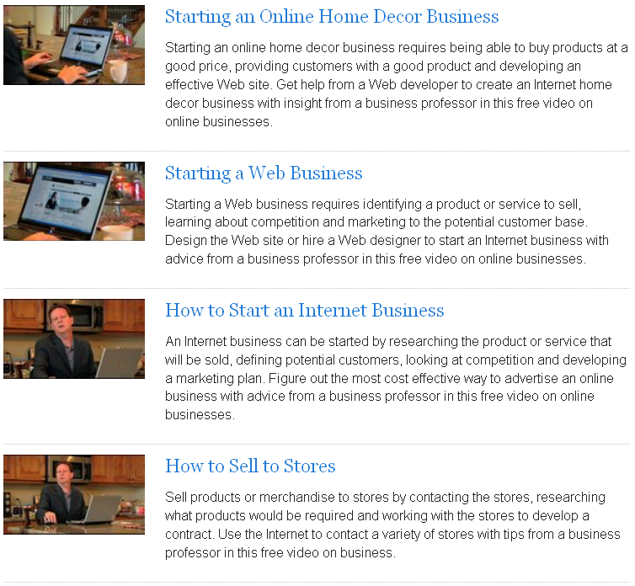
1 fig. Online business.
You will need to learn what it takes to get the website found by the search engines and how to attract traffic to it. It is fairly straightforward but can take some time to implement. It will include a plan of getting back links and creating content based on the keyword research you have done on your business topic.

1.4.2. Create an Online Presence
Build a content website for your profitable keywords which direct you to the user that you are targeting. Remember, an Internet user is looking for information and not sales talk. So use your content to show them your expertise in your area. Write your content in such a way that your user stays and browses through your site instead of hitting the 'back' button. Write just how you talk for the most part. Talk to your user through your content and pre-sell them the product you want to sell - information/product/your offline business etc. Pre-selling using content builds confidence in your user.
Monetize your site. Use Google AdSense and/or Yahoo Publisher Network on your site to monetize. Follow some easy to follow tips given by Google for posting AdSense ads on your site that will make you money. Find affiliate programs that are compatible with your business topic and promote them to your readers.

Finance your Endeavour
Research and select an online payment processing service so that you can provide your customers with a wide array of payment options, such as credit card, e-wallets, PayPal, or even bank transfers.
Use other ways of monetizing as well if you are not an entrepreneur.
Use article marketing to start promoting affiliate products without having a website to fund your website business. This can be an online business in itself.

Miscellaneous
Find a mentor, the person who has a good success system to follow! Find a direct sales model. It's the fastest way to break-even.
Tips:
- Find a business system that has been proven successfully.
- A thing that needs to be ironed out for your online business is your billing service. While there are businesses that may bill their clients directly after a contract has been agreed upon and signed and these bills are paid for through checks that are deposited into the service provider's bank account, there are some clients who require a certain online billing system for them to pay for the services they have contracted. You may need to register with a billing system like PayPal for your online business to make billing and payment easier and less of a hassle to you and your clients.
- Putting up an online business may be easy or hard, depending upon whether you did your research well and laid down all the groundwork before you began. You can make money out of an online business if you execute the necessary steps and do not miss out on some of the essentials that are needed for an online business to succeed.
Warnings:
- Watch out for website hosting and building services that do not handhold you through the process of building an e-commerce website.
- Keep in mind that it is a business. Learn not only from your failures but also the success of others. Be a willing and eager student.
- Never give out your money to anyone to show you how to make money. Please be very cautious before spending a penny.
- PayPal is limited as a payment processor because when people use their debit/credit cards through them they lose the ability to get refunds directly.
Things You'll Need:
- A website with a domain name that you can acquire from a website hosting service.
- A good training system to follow with step-by-step details.
- It is much more profitable to outsource when you are beginning to start an Internet business. This will ensure that you have experts doing the work for you instead of you trying to figure it all out.

Growth of social software for communication
Yet it is still a giant industry and remains relatively healthy overall. It remains the case that it is the enterprise where the big value - and money - in software lies. In fact, the latest data puts the global enterprise software industry at $120 billion in 2012, which in contrast to IDC they put at 4% growth from last year overall.
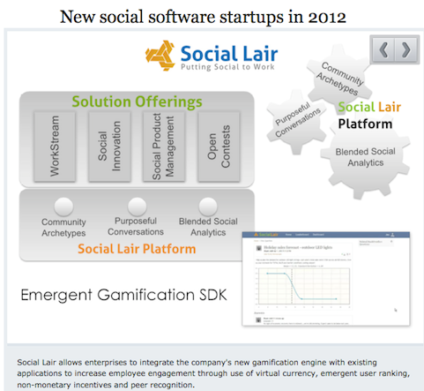
2 fig. Social software.
ERP, office suites, business intelligence and CRM is round out as the largest individual categories for software at the moment. Interestingly, SaaS and cloud, which gets an inordinate amount of press compared to traditional software, will only account for about 13% of software spent this year, showing steady yet relatively modest growth (online example http://www.zdnet.com/blog/hinchcliffe/enterprise-2-0-a-bright-spot-for-software-in-2012/2150).

Learning unit 2. Web 2.0 tools for business management at small and medium enterprises
It empowers individual consumers and provides additional communication channels for comment, feedback, and involvement in shaping product and service development and experience. It is also a tool for human empowerment, liberation and advancing the cause of freedom, including the freedom to start a business.

2.1. Blogs

3 fig. Blog.com web site.
A blog is a web page made up of usually short, frequently updated posts that are arranged chronologically-like what’s new page or a journal. Blogs are defined by their format: a series of entries posted to a single page. There are many different types of blogs, differing not only in the type of content, but also in the way that content is delivered or written:
- Personal blogs (The personal blog, an on-going diary or commentary by an individual, is the traditional, most common blog. Blogs often become more than a way to just communicate; they become a way to reflect on life, or works of art. Blogging can have a sentimental quality).
- Corporate and organizational blogs (A blog for business purposes, used internally to enhance the communication and culture in a corporation or externally for marketing, branding or public relations purposes are called corporate blogs. Similar blogs for clubs and societies are called club blogs, group blogs, etc.; typical use is to inform members and other interested parties of club and member activities).
- By genre (Some blogs focus on a particular subject, such as political blogs, health blogs, travel blogs (also known as travelogs), gardening blogs, house blogs, fashion blogs, project blogs, education blogs, niche blogs, classical music blogs, quizzing blogs and legal blogs (often referred to as a blawgs) or dreamlogs. Two common types of genre blogs are art blogs and music blogs. A blog featuring discussions especially about home and family is not uncommonly called a mom blog. While not a legitimate type of blog, one used for the sole purpose of spamming is known as a Splog).
- By media type (A blog comprising videos is called a vlog, one comprising links is called a linklog, a site containing a portfolio of sketches is called a sketchblog or one comprising photos is called a photoblog. Blogs with shorter posts and mixed media types are called tumblelogs. Blogs that are written on typewriters and then scanned are called typecast or typecast blogs).
- By device (Blogs can also be defined by which type of device is used to compose it. A blog written by a mobile device like a mobile phone or PDA could be called a moblog. One early blog was Wearable Wireless Webcam, an online shared diary of a person's personal life combining text, video, and pictures transmitted live from a wearable computer and EyeTap device to a web site. This practice of semi-automated blogging with live video together with text was referred as surveillance. Such journals have been used as evidence in legal matters).
- Reverse blog (A Reverse Blog is composed by its users rather than a single blogger. This system has the characteristics of a blog, and the writing of several authors. These can be written by several contributing authors on a topic or opened up for anyone to write).
Blogs generally represent the personality of the author or reflect the purpose of the Web site that hosts the blog. Topics sometimes include brief philosophical musings, commentary on Internet and other social issues, and links to other sites the author favours, especially those that support a point being made on a post. The author of a blog is referred to as a blogger.
A blog can serve as a great networking tool. A blog is a great place to inspire people and build a subscriber base. By giving your voice a platform and reaching out to other fellow business bloggers, you have the ability to establish a solid business-to-business network.
The features that make blogs different from other websites are:
- content is published in a chronological fashion,
- content is updated regularly,
- readers have the possibility to leave comments,
- other blog authors can interact via trackbacks and pingbacks,
- content is syndicated via RSS feeds.
Blogs are extremely useful, both to the writer and the reader. The writer may have a lot of knowledge to share, and the reader may want an informal way to learn about a topic. Some people use blogs to find other people with similar problems, issues or situations. Blogs can be anonymous, which helps a lot of people share information without being known. They also offer many advantages compared to static websites:
- Blog software is easy to use. Simply write your thoughts, link to resources, and publish to your blog, all at the push of a few buttons.
- Blogging is a low-cost alternative to having a web presence. For small business owners without the time to learn web html or the money to hire a designer/developer, blogging offers an inexpensive method to get your name out on the Internet.
- Updating the weblog is a much quicker process than contacting a web designer with changes or doing the coding and uploading data yourself.
- Business blogs provide your small business with a chance to share your expertise and knowledge with a larger audience. It is a powerful benefit for consultants and knowledge workers.
- It makes it easy to add and update content, so there's always something fresh on the site.
- It helps establish a relationship with visitors and build a climate of trust.
The most technical part of building a blog is installing it, which can be done with a few clicks of a button. But even that can be done off with, if you choose to start a blog using an online service like free blog platforms - Blogger, Wordpress, Typepad, Tumblr. You can create an account in a few minutes at any of those sites and start blogging.

2.2. Wiki
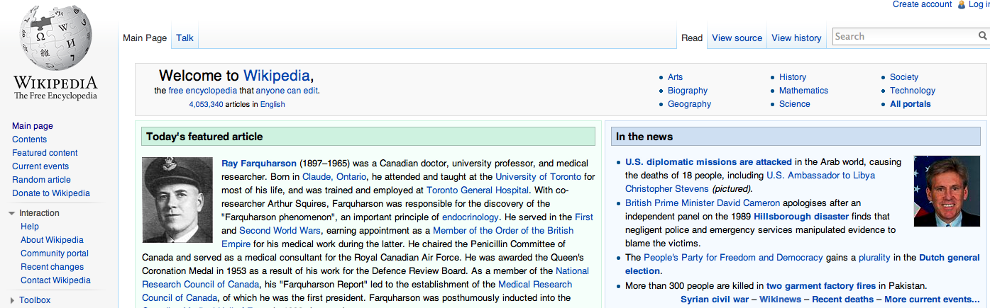
4 fig. Wikipedia.com web site
A wiki is a server program that allows users to collaborate in forming the content of a Web site. With a wiki, any user can edit the site content, including other users' contributions, using a regular Web browser. Basically, a wiki Web site operates on a principle of collaborative trust.
A wiki allows visitors to the “wikified” Web site to edit the content of the site from their own computer. Visitors can also create new content and change the organization of existing content. The simplest wiki programs allow editing of text and hyperlinks only. More advanced wikis make it possible to add or change images, tables, and certain interactive components such as games.
Wikis are considered a Web 2.0 technology, and provides a simplified interface. At any time, contributors can conveniently view the Web page as it looks to other subscribers, before and after the changes they have made. It is not necessary to know HTML (hypertext mark-up language) or perform work in HTML code. The best-known example of a wiki Web site is Wikipedia, an online dictionary building collaboration.
The Wikipedia is one of the largest knowledgebase wikis, an extensive online encyclopaedia. It has now come under a non-profit organization, the Wikimedia Foundation. The Wikipedia is a good example of a wiki that stays very professional, and very on-task with its professional goals, even though the contributors are random volunteers from all around the world.
Wikis are available through a wide variety of services and open-source software tools. Generally there are the following two categories of wikis:
- Wiki services or Wiki farms: the wiki pages are hosted at the service provider server or array of servers, which require no local software installation and can be either free or fee-based. A comparison of many Wiki farms can be found at http://en.wikipedia.org/wiki/Wiki_farm. The most popular wiki servers:
  - Wikispaces (http://www.wikispaces.com/),
  - Wetpaint (http://www.wetpaint.com/),
  - Nextdo.com (http://www.nexdo.com/),
  - PBwiki (http://pbwiki.com/),
  - Wikia (http://www.wikia.com/),
  - Google Sites (http://sites.google.com/),
  - Netcipia (http://www.netcipia.com/).
- Self-hosted Wikis: there exists a variety of open source wiki software like MediaWiki and TWiki. The advantage of self-hosting the wiki allows for maximum control over the access and security as well for fullﬁlment of speciﬁc requirements. A disadvantage is the necessity of an own server and some technical and network experience which results in longer start-up time. Most popular wikis are as follows:
  - Media Wiki (http://www.mediawiki.org/),
  - PBwiki (http://pbwiki.com/),
  - Deki Wiki (http://www.mindtouch.com/Products/MindTouch_Deki_Standard),
  - TikiWiki (http://info.tikiwiki.org/tiki-index.php).
Choosing the right wiki can be based on answering some question regarding the key features of
wiki, the available resources and technical support.

2.3. Google mail
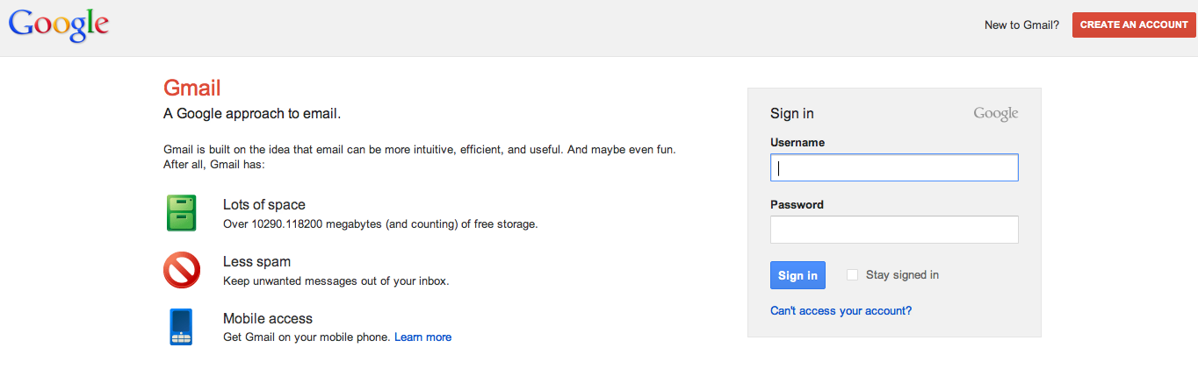
5 fig. Gmail.com web site.
Gmail is a free, search-based e-mail (one of the world's most popular Web mail) service, which is accessible from a Web browser anywhere in the world. Gmail is a web based email service that stores all messages and attachments on the Google server. This makes it convenient for the following reasons:
- You can always access your email from anywhere with an Internet connection.
- You never have to worry about losing any messages or attachments if your computer or other devices crash.
- There are no bloated Deleted or Sent folders on your computer.
- Gmail works with any version of operating system (OS).
- POP and powerful IMAP access bring Gmail to any email program or device.
- It is fast. Most messages are delivered within minutes – sometimes seconds – around the world without the inconvenience and cost of using a postal service. In fact, postal service is often referred to as “snail mail” by email users.
- It's personal. While the nature of email is informal, its efficiency is an excellent substitute for telephone conversations.
- You can think through your response. Like a letter, you can type your reply and make changes before sending.
- The sender and the receiver do not have to be working at the same time. Email avoids problems such as telephone tag or trying to contact someone in a different time zone.
- Email makes it easy to keep a record of your communication. You can save and refer to later copies of the emails you send as well as those you receive.
- You can reach a lot of people at once. It is possible to send one message to hundreds of recipients at once, or you can send a private message to one individual.
- Gmail is also available in dozens of languages.
Gmail is a really smart email service that boasts of a huge and growing amount of email storage, more than 10,000MB (ten gigabytes). Your storage use is based on the size of all of the messages and attachments in your mail, including those in Spam and Trash. You can check how much space you're using and your storage limit at the bottom of any Gmail page.
Gmail provides some of the best email organization on the Internet. Gmail's interface is simple and elegant, but also remarkably clever with useful keyboard shortcuts and speedy operation. Now it shows participants user pictures, which helps identity contributions. Interface fonts resize as you resize the browser window, letting you choose among “comfortable,” “cosy” and “compact.” All of the familiar functions are there (composing an email, forwarding, carbon copying, etc.) with enhanced capabilities. Gmail’s pride and joy feature is the “conversation” interface. Instead of having a list of back and forth emails between you and a friend or co–worker all replies and sent messages are filtered into one line of inbox with a corresponding number of messages in that conversation. Your contacts and everyone you have ever emailed will be stored in Google Contacts and will come up as suggestions as you type in names. To attach files you can simply drag the document from your desktop into the message. You can sort messages with labels and filters, prioritize which kinds of emails you see when you open Gmail, and easily search for any term/person/subject in your entire history. Additionally, you can create custom filters and have all your messages sorted by, “from”, “to”, “subject,” “has the words” and “doesn’t have.” Messages can be places into labels (folders), stared, deleted or forwarded.
The backbone of Gmail is a powerful Google search engine that quickly finds any message an account owner has ever sent or received. When Gmail displays an e-mail, it automatically shows all the replies to that e-mail as well, so users can view a message in the context of a conversation.
Priority Inbox can help save you time if you’re overwhelmed with the amount of email you get. It attempts to automatically identify your important incoming messages and separates them out from everything else. Gmail uses a variety of signals to prioritize your incoming messages, including who you have emailed and chatted with most and which keywords appear frequently in the messages you opened recently.
Gmail includes an instant messenger program without an additional download. If one of your contacts is signed into their account, you can chat with them. If you both have webcams, Gmail is equipped with video chat software too. With Gmail’s mobile access, you can send and receive emails through your Smartphones or other mobile device, also place and receive phone calls to any landline or mobile phone number in Gmail. It also offers a downloadable notifier for your computer.
Homepage customization is another Gmail’s unique feature. To customize your homepage you can choose from a list of several RSS feeds provided by Google, or you can import your own RSS feed from your favourite websites and arrange them on your homepage.
Offline Google Mail uses HTML5 storage to allow reading and composing emails while your computer is not connected to the Internet. Gmail offline only runs in its own Chrome browser.
Signing up for a Gmail account opens you up to a world of other Google services as well as e-mail - Picasa online photo albums, Blogger blogs, cloud storage service Google Drive, Docs for word processing, spreadsheets, presentations, and YouTube video sharing, and now the Google+ Facebook clone. Other sites usually allow you to sign in with your Google account, via its OpenID support (a capability shared by Yahoo and AIM Mail but not Hotmail) and more.
Google Docs is a suite of web-based office applications that automatically saves your work, helps you collaborate and share with others, and access your documents from anywhere at any time. The applications are familiar and easy to use, including word documents, spreadsheets, presentations, forms, and even a drawing space. All content produced in these applications can be shared with other users, who can view and edit them in real time. Google Docs also gives you storage room for images, videos, and pdfs.
Google Calendar is the standard web-based calendar. Scheduling events, inviting others, and finding times that work has never been easier. It is accessible anywhere via the Internet (and even offline, now) and it will play nicely with your other devices (Smartphones, tablets, etc.).
Google Reader is a fast and convenient way to read stories you are interested in, all in one location. Like other RSS readers, Google Reader will aggregate content from websites (blogs, news sites, etc.) that you choose to include in your account and present them in a clear, streamlined format updated in real time. So whether you are skimming the headlines of the Washington Square News or reading the latest reflection from John Sexton, Google Reader is your one-stop shop.
These features are great for group projects at school or work, where all members of the team can access the same material. And for additional fee you can upgrade everything and use it for business purposes.

2.4. Skype
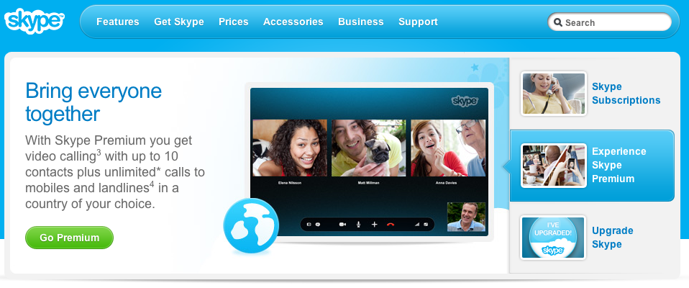
6 fig. Skype.com web site.
Skype is a proprietary voice-over-Internet Protocol service and free software application. Unlike most other VoIP services, Skype is a hybrid peer-to-peer and client–server system. It makes use of background processing on computers running Skype software. Skype's original proposed name (Sky Peer-to-Peer) reflects this fact.
The service allows users to communicate with peers by voice, video, and instant messaging (IM) over the Internet. The connection can be between just two people or can involve a group of folks from multiple locations. Phone calls may be placed to recipients on the traditional telephone networks. Calls to other users within the Skype service are free of charge, while calls to landline telephones and mobile phones are charged via a debit-based user account system. SkypeIn and SkypeOut are fee based extras, but they might be the more affordable alternatives when a caller or call recipient are at a remote location, or when Internet access is not available (voicemail is included). Here is the deal:
- From your Skype account, you can contact anyone else with a Skype account for free.
- For a fee, you can use Skype to call any landline or cellular number. This includes international calls.
- You can use SkypeIn to get a phone number for your Skype account – that means friends and family who do not use Skype can call a regular phone number that will “ring” you at your Skype account. SkypeIn comes with a free Skype voicemail account.
- You can also use Skype to do video calling.
Skype has also become popular for its additional feature, file transfer. Skype allows you to send large files to friends or colleagues, an important feature when so many providers limit the size of e-mail attachments, to exchange photos, drawings, documents, and more. Skype brings people together, helping you overcome the barriers of cost, distance and technology and allowing you to do more anywhere in the world. You can set up and start using Skype in no time. Here is a list of all you need to have to be able to use Skype:
- Computer, Smartphone or smart TV and Internet connection.
- Speakers or earpieces and microphone.
- The Skype software, which is freely downloadable from www.skype.com.
- One or more persons to communicate with. They need to be Skype users as well. If they are not, you can still access them through their normal phones.
Skype has great functionality that can be used to help drive your communications:
- See the selected online status of others and call them for free. You can view the selected online status of contacts on Skype and contact them immediately via free Skype-to-Skype calls or IM.
- Have face-to-face meetings. You can have face-to-face meetings at your desk with people anywhere in the world using Skype-to-Skype video calls.
- Contact groups of people at the same time. You can use multi-person video conferencing that's easy to set up, or create group IMs to use as discussion spaces or to share important information instantly over Skype.
- Share knowledge. You can share your screen with others to conduct presentations remotely or to just let them see what you're seeing.
- Transfer files. You can send and receive large files via Skype, ensuring that information gets to your colleagues when it is needed.
You’ll discover more flexible ways of working together with Skype.

2.5. RSS
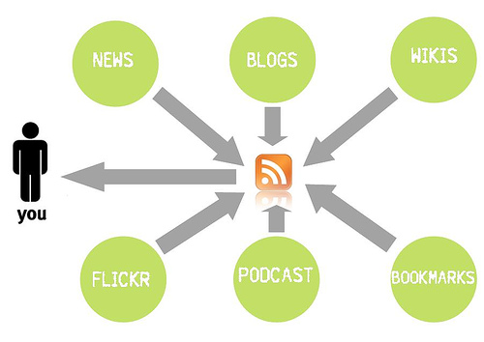
7 fig. RSS data flow.
RSS - stands for “Really Simple Syndication” or “Rich Site Summary” is a way of publishing frequently updated web-based content in an open format (XML), which can be easily republished on other websites, and in apps. An RSS document includes full or summarized text, plus metadata such as publishing dates and authorship. One of the most common uses of RSS is for websites that are regularly updated - such as a news sites, photo-sharing applications, podcasts or a blogs. As well as the version of the website that you see when you visit it in a browser, the site also generates a machine-readable version of the most recent content, called the RSS ‘feed’. This is then used to display the content in other places.
To pull out and display RSS ‘feed’ you need a program called an RSS “reader” or “aggregator”. RSS “reader” is an app or a small software program (web-based, desktop-based, or mobile-device-based) that lets you collect a whole load of feeds into one place. It allows you to easily stay informed by retrieving the latest content from the sites you are interested in. You save time by not needing to visit each site individually and ensure your privacy, by not needing to join each site's email newsletter.
A variety of RSS Readers are available for different platforms. Some popular feed readers include Amphetadesk (Windows, Linux, Mac), FeedReader (Windows), and NewsGator (Windows - integrates with Outlook). There are also a number of web-based feed readers available. My Yahoo, Bloglines, and Google Reader are popular web-based feed readers.
Probably the easiest way to start using an aggregator is to have a play with Google Reader. You will need to visit google.com/reader and login with your Google account details (probably a Gmail account). If you do not have one, you will need to create one. Your Reader page will look pretty empty to begin with, but it’s easy to start to populate it. Just click the ‘Add a subscription’ button and type or paste in the web address of your favorite website or blog. If it produces a feed, Reader will find it and start importing the content for you. If it does not produce a feed, then Reader will try and create one for you, by analyzing the site’s content. Sometimes this works, sometimes it doesn’t! Many sites display a small icon with the acronyms RSS, XML, or RDF to let you know if a feed is available.
You can build up your subscriptions and organize them into folders and tags to help you keep track of them. If something is worth revisiting later, you can star it for future reference, or share it with others. This latter action adds the article to a public web page with all your shared items on it, which you can promote if you wish, or just use as a personal scrapbook.
You can also use RSS feeds to add content from other websites onto your own. For example, if you have a website, you could have the news from sources that interests you published automatically on your site, through RSS. If you produce web content yourself, it is a really good idea to ensure that it is available as an RSS feed. Consider the following uses for RSS:
- PDF Documents - Consider broadcasting meeting agenda notes or documentation as a PDF included with a feed, allowing interested individuals to access information without having to deal with cumbersome e-mail attachments.
- PPT Presentations - Presentations can easily be distributed in a feed enclosure. The added benefit is that presenters using Power Point will not have to lug their notebook to a meeting to present - they can manage the presentation from an iPod or similar handheld that reads RSS feeds.
- Video - Video or streaming video are both possible via the enclosure field. Have lectures or even political debates come to life with the added video component.
- Audio - Audio content does not mean that feeds are limited to your favorite songs. Podcasting is the coined term for audio content contained in a feed and can include language instruction, talk shows or editorials.
- Images - Imagine realtors using the enclosure field to display photos of homes to interested buyers. Now they can carry a lightweight catalogue with them to show potential buyers at a moment's notice.
- Downloads - Consider an information technology department in a large corporation conducting proprietary software updates, including executable or zip files in the enclosure field which allow users to update the software at a convenient time.
It makes it really easy for others to keep a track of it, and means you can easily make the content available in other mediums, such as in social networks like Twitter and Facebook, or even email.

2.6. Twitter
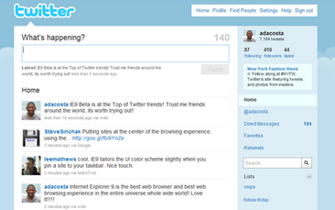
8 fig. Twitter main window.
Twitter is an online service that enables you to broadcast short messages to your friends or others called “followers”. It’s an online social networking and micro blogging service that enables its users to send and read text-based messages of up to 140 characters, known as “tweets”. Twitter users follow others or are followed. The relationship of following and being followed requires no reciprocation. A user can follow any other user, and the user being followed need not follow back. Being a follower on Twitter means that the user receives all the messages (tweets) from those the user follows. Many tweets do answer the question of what the user is doing, but plenty of others are responses to other tweets, pointers to online resources that the user found interesting, musings, or questions. The tweets appear on your page in the form of a timeline (newest tweets at the top going down to oldest at the bottom).
Once you have published a message, other Twitter users have several options. They can:
- Send you a message back responding to what you have said.
- Follow you (if they are not already doing so).
- Retweet the message (send the message in its entirety to their own followers). It’s retweeting which has the potential to send messages around the internet like wildfire, bringing your messages to the attention of news organizations (if the messages are news-worthy) and can bring you more and more new followers every day. The retweet mechanism empowers users to spread information of their choice beyond the reach of the original tweet’s followers.
- Continue the conversation by sending out a Twitter message of their own, about what you have said.
- A combination of the above.
Users can tweet via the Twitter website, compatible external applications (such as for Smartphones), or by Short Message Service (SMS) available in certain countries. While the service is free, accessing it through SMS may incur phone service provider fees. For example, users can receive Twitter messages as a text message on their cell phone, through a Facebook application that users have added to their Facebook account to see the messages when they log in, via email, as an RSS feed, or as an Instant Message (with a choice of Jabber, GoogleTalk etc.). Figure 1 shows the various input and output vectors to send and receive Twitter status update messages (“tweets”).
9 fig. Twitter input and output methods.
During time, common practice of responding to a tweet has evolved into well-deﬁned markup culture: RT stands for retweet, ’@’ followed by a user identiﬁer address the user, and ’#’ followed by a word represents a hashtag. This well-deﬁned markup vocabulary combined with a strict limit of 140 characters per posting conveniences users with brevity in expression.
A Twitter user keeps a brief proﬁle about oneself. The public proﬁle includes the full name, the location, a web page, a short biography, and the number of tweets of the user. The people who follow the user and those that the user follows are also listed.
Twitter can be used like:
- a way to connect and network with others in your industry or others who share you views.
- a way to get instant access to what’s being said, this minute, about your organization, people, products, or brand.
- a steady stream of ideas, content, links, resources, and tips focused on your area of expertise or interest.
- to monitor what’s being said about your customers to help them protect their brands.
- to extend the reach of your thought leadership – blog posts and other content.
- to promote your products and services directly to a target audience.

Learning unit 3. Computer based marketing solutions and communication in real time
What is the future of real-time video communication and what will it feel like to live and work in a world where real-time video is ubiquitous?
Video technologies are improving dramatically and rapidly, supporting mobile and ubiquitous real-time video experiences. Low cost, simple platforms for real-time video will become an essential part of the way we communicate with each other, and will spawn the next generation of consumer behavior, business practice, media culture and economics, and innovation policy.

3.1. Camtasia
Camtasia Studio is a video-based screen capturing software program published by TechSmith. The software is the complete professional solution for recording, editing and sharing high-quality video. It is analogous to using a video camera to record screen. However, unlike using a video camera, the software is installed on your computer, so your screen captures are directly recorded to a digital video format with high quality audio. Camtasia can be customized to capture the entire screen, a specific window, or user-defined region. It also has ability to record the view from web camera. Screen capture videos can be recorded with or without voice narration from an input source, and can be annotated after recording.
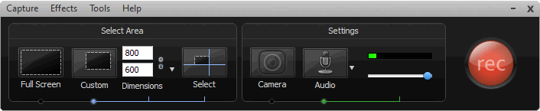
10 fig. Camtasia Studio Recorder.
Camtasia Studio makes it very easy for non-technical people to create training videos, demonstrations, presentations and screencasts. The video that is produced is high quality with clear audio recording, and a variety of editing tools for fine-tuning.
It allows you to capture exactly what you are doing when working on your computer. It automatically records exactly what you see on the screen and can record what you say into a microphone or record from your webcam. It can capture how you interact with any application or Internet-based website.
With the power of interactive Camtasia Studio videos, you can deliver high-quality content anytime, to even your most remote audience. It helps you keep pace in a mobile world by making it easy to publish videos and MP3 files for portable media players. Now your message, screencast, lecture, or just-in-time training video can reach your audience practically anywhere – on the bus, in a coffee shop, or while they’re jogging. Camtasia Studio videos are simply designed to share. You can burn the video to a CD-ROM, post to a web site, Flash-based formats (SWF, FLV), or even upload the file into VLE (virtual learning environment) for delivery through an online course.
Camtasia was originally designed for creating software tutorials, but has other powerful applications. Common uses of Camtasia are:
- Software tutorials for discipline-specific or lab software,
- Explanation of a process displayed in discipline-specific software,
- Web site tours,
- Narrated PowerPoint presentations,
- Narrated explanation of lecture notes, homework solutions or other materials,
- Video and audio podcast production.
Here are the tools in Camtasia that allows enhancing your videos:
Library lets you store content that is drag-and-drop easy to use. You can use the library to save images, audio files, video, and callouts for future use and then just drag and drop them into any project.
Callouts give the ability to add text in ready-made shapes like arrows, speech bubbles, and more to communicate information to the viewer. You can customize your callout with new fill and border colors, and even rotate the callout a full 360 degrees on the screen.
Sketch motion feature gives the ability to make it look like you are drawing on the screen in real time. So, say you want to point something out to the user of your video; all you have to do is just drop this on your timeline and stretch it to fit the duration. This gives you the ability, for example, draw a circle around a specific point on the screen that you want to emphasize.
Keystroke Callouts lets you show your viewers exactly what keystrokes you used in your video and when they were used. From the callouts menu, you click on the traditional keystrokes and it can show the keystrokes that you are using at that point or you can specify what keystrokes you want the video to display. As with all callouts, you can change the style and how the callouts looks on screen.
Cursor effects will give more flexibility and more eye-catching visuals that you can use in your video. You can highlight your cursor, put a spotlight on it, use sound effects, make it larger, make a ripple ring, or warp effect so that each time you click the viewer will know exactly where the cursor is on the screen. These can be applied to the entire timeline or to specific frames within your timeline to emphasize a specific point.
Audio enhancements allow you to be in full control of what your viewers hear. At any point throughout the timeline you can fade the sound, increase the sound, fade it out, or silence it altogether.
Copy and paste right on the timeline gives you the ability to perfect a specific portion of your video and then copy that portion to another point on the timeline and paste it in complete. You can also take that portion and, instead of copying it, save it to the library for use in another video or to share with others.
YouTube integration is as easy as going to the “Produce and Share” tab to post it to YouTube. After you login to your user account — this can be saved for future logins — you can produce and upload your video from within Camtasia Studio. You can share it with the world or keep it private. You also have the ability to designate options such as what categories to post it in.
SmartFocus technology will provide a noticeable increase in accuracy so you will spend less time editing while being able to deliver clear video content for playback on nearly any screen size.
It provides the ability to create surveys, questionnaires and scored quizzes and the output options include an HTML5-enabled custom player. It is SCORM compliant. There is also a PowerPoint plug-in that allows you to take your presentations and turn them into videos.
Camtasia Studio also has a lot of tutorial videos that will help you get up to speed fast.

3.2. Adobe Connect
Adobe Connect is a web-based meeting/classroom environment for web collaboration in administrative meetings for multiple users and sharing presentations, images, and desktop applications with remote participants. The meeting room is an online application that you use to conduct a meeting. The meeting room consists of various display panels (pods) and components that contain various types of media. There are several prebuilt meeting room layouts, or you can customize a layout to suit your needs. The meeting room enables multiple users, or meeting attendees, to share computer screens or files, chat, broadcast live audio and video, and take part in other interactive online activities. Once you create a meeting room, it exists until you delete it. The meeting room location is a URL, assigned by the system when the meeting is created. When you click the URL, you enter the virtual meeting room. A meeting room can be used over and over for the same weekly meeting. The host can leave the meeting room open or closed between scheduled meetings.

11 fig. Adobe Connect interface.
Adobe Connect allows participants in different locations to meet online to discuss, collaborate and share materials. Web conferencing can be used to teach and communicate with those who are geographically dispersed or wish to collaborate remotely.
Adobe Connect can be used when need to:
- conduct web meetings to share screens or applications,
- deliver online training in real time, on demand, or offline,
- facilitate webinars that capture the attention of participants with interactive multimedia content.
There are three roles for meeting attendees:
- Hosts set up a meeting, can invite guests, add content to the library, share content, and add or edit layouts in a meeting room. They can promote other participants to be host or presenter.
- Presenters can share content pre-loaded in the meeting room library or from their computer.
- Participants can view the meeting’s shared content and can hear and see the presenter’s broadcast. They can also use text chat and use a microphone to speak.
With Adobe Connect, you can captivate your audience with rich, engaging, and interactive experiences, shorten the time required to train users and make them available to virtually anyone, anywhere, on virtually any device, with just a click of a button. Adobe Connect allows invitees to easily attend your meetings from the desktop without requiring a client download, and offers complete mobile-to-mobile collaboration capabilities worldwide. It advantages in five key areas that sets Adobe Connect apart from other web conferencing solutions:
Ease of access - Adobe Connect is based on Flash Player. Because Flash Player is installed on virtually all Internet - connected computers, participants can get directly into a meeting without a separate download.
Rich interactions - with Adobe Connect, presenters can completely define their meeting environment, with the ability to easily switch between layouts, arrange pods as needed, utilize multiple pods in the same screen (for example, multiple notes and sharing pods simultaneously) and arrange the flow of training content, either prior to a meeting or on-the-fly. The environment can also be branded to reflect corporate standards and images. In addition, presenters can share virtually any kind of content (including high-quality video and interactive presentations) confidently, knowing that anyone in the meeting will be able to view the content.
Security and compliance - Adobe Connect supports a variety of compliance requirements, making it the solution of choice for organizations in which security and compliance are top priorities.
Extensibility - Adobe Connect has been built from the ground up on the latest technology with a focus on extensibility, cross-platform access, and a rich user experience as key components. It integrates seamlessly with other elements of the communications infrastructure (such as Microsoft products) and includes prebuilt adapters that enhance extensibility. It is based on ActionScript 3.0, so any flex developer can develop extensions to Adobe Connect.
Single web conferencing solution - more and more enterprises are choosing Adobe Connect as a single web conferencing solution to handle web meetings, webinars, eLearning, and myriad other use cases. Because of the solution’s richness and flexibility, it can support virtually all use cases in the enterprise.
With flexible deployment, customizable promotional templates, tight integration with powerful content creation and analytics tools, and seamless delivery of content across devices, Adobe Connect is ideal for any organization committed to delivering high-impact web conferences to showcase its products, services, and ideas.

3.3. YouTube
YouTube is a free web-based service that allows people to discover, watch and share videos across the Internet through websites, mobile devices, blogs and emails. It allows users to upload files to YouTube servers easily, where they are available online. With the exception of content that is offensive or illegal, videos can be animations, footage of public events, personal recordings of friends - virtually anything a user wants to post. The site has grown into the web's premier multimedia entertainment destination with more than 100 million videos viewed daily, ranging from clips of just a few seconds to 10 minutes, even hours or more. In fact, every minute, 72 hours of video are uploaded. Videos are informational, entertaining, persuasive, or purely personal.
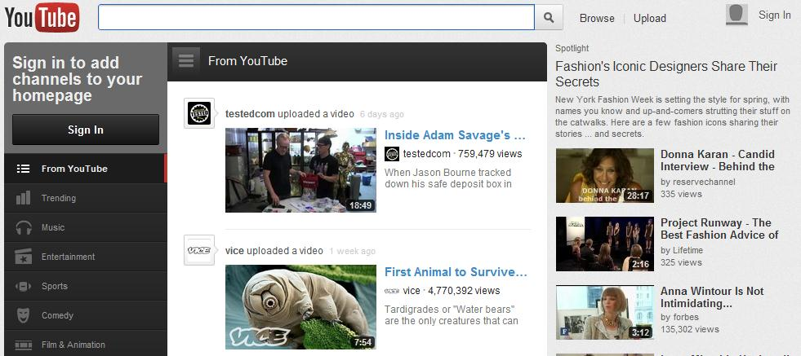
12 fig. YouTube web page.
YouTube is free, though people who want to post videos, comments or do other activities must register with the site, creating a profile. Since Google owns YouTube, you can use your existing Google account to log into the system.
YouTube provides an easy to use interface, a robust connection, and the largest collection of videos on the Internet:
- An immense number of teaching videos, where someone (teachers, people in various jobs and professions and other people) who knows something teaches others.
- A wealth of useful explanatory video on practically EVERY subject.
- Video-based learning matches many (if not most) students’ preference.
- The ability to see, hear, and learn from, top experts in any field.
- The ability to research and view the huge and growing number of primary-source, historical videos available.
- The ability to mentor, coach and guide others.
- And many more.
These videos are delivered in a streaming Flash format, which efficiently uses bandwidth as the trade-off of image quality. YouTube accepts videos uploaded in most container formats, including .AVI, .MKV, .MOV, .MP4, .DivX, .FLV, and .ogg and .ogv. These include video formats such as MPEG-4, MPEG, VOB, and .WMV. It also supports 3GP, allowing videos to be uploaded from mobile phones. YouTube launched a version of the site that uses the built-in multimedia capabilities of web browsers supporting the HTML5 standard. This allows videos to be viewed without requiring Adobe Flash Player or any other plug-in to be installed. In this case videos on YouTube can be watched even in devices, which do not support Flash technology, such as Apple products with OS X.
There are easy-to-use communication and feedback channels built in to get feedback from and interact with users who seek out content that interests them. YouTube allows users to post and tag videos, watch those posted by others, post comments in a threaded discussion format, search for content by keyword or category, create and participate in topical groups. YouTube ties into several blogging applications, giving users a quick way to blog about a particular video and include a link to it. Users can view profiles of individuals who have posted or commented on videos, see their favorite videos, and contact them. Videos can be public or restricted to members of specified contact lists that way can be controlled who can watch it.
Links allow a user to share a movie through - email, add it to a list of favorites, post a text-based or video comment about it, and read (or watch) the comments others have posted.
A user can subscribe to all of another user’s postings or to content that is tagged with particular terms. Each of these actions becomes a part of the user’s profile. When others look at a user’s profile, they see his favorites, comments, and videos he has posted. As a result, profiles are constantly updated to reflect each user’s history and tastes. YouTube also allows videos hosted on its site to be embedded in other Web pages, such as blogs or personal Web sites such as in an e-portfolio or on a course Web site.
YouTube enables you to record video directly from the website and edit it right in YouTube, using built-in tool - no software downloads required:
- combine your video clips, trim the length of your video, add music using AudioSwap (adds music to your videos for free), and add transitions between video clips.
- set the caption/subtitle options, select the language for the subtitles (YouTube will automatically translate the audio of the video and display it as subtitles, when available).
- add text links to your videos using annotations (link to other videos, channels and playlists, or even create interlinked video narratives. You control what the annotations say and when and where they appear on the video)
- view videos in 3D.
- rent full-length feature films straight from YouTube.
YouTube Live is a newest YouTube service that provides live event streaming in real time in HD quality video and an unlimited streaming time which is pretty important for big events like concerts and sporting events etc.
Why you should use YouTube for your business?
- Video can build trust with your customer. When they get to hear you and see your business, you become more tangible and therefore more trustworthy then just a photo and text. You can use YouTube to host the videos and then embed them on your site, in your Google local lists. People of all ages respond well to videos, but you better be using video if want to appeal to the younger generation.
- Create some Google “Juice.” Videos that are uploaded to YouTube are indexed almost immediately and therefore will appear in the search results much quicker then uploads or new content on your website. Google wants to demonstrate a range of search results from text, images, especially, video. Therefore it is common for YouTube videos to be placed higher in search results then a company’s website. By linking all of your videos back to your website you will direct traffic to your site and improve its Google Page rankings.
- Getting to Know You – Studies show that the longer a customer is exposed to your site the more likely they are to buy from you. Video is a great way to capture and maintain a person’s interest.
YouTube offers opportunities for expression through video — a new spin on the notion self-publishing, making content available for anyone interested in consuming it.

Learning unit 4. Research tools for computer based marketing and data analysis
Marketing research is the function that links the consumers, customers, and public to the marketer through information — information used to identify and define marketing opportunities and problems; generate, refine, and evaluate marketing actions; monitor marketing performance; and improve understanding of marketing as a process. Marketing research specifies the information required to address these issues, designs the method for collecting information, manages and implements the data collection process, analyzes the results, and communicates the findings and their implications.
It is the systematic gathering, recording, and analysis of qualitative and quantitative data about issues relating to marketing products and services. The goal of marketing research is to identify and assess how changing elements of the marketing mix impacts customer behavior. The term is commonly interchanged with market research; however, expert practitioners may wish to draw a distinction, in that market research is concerned specifically with markets, while marketing research is concerned specifically about marketing processes.
Marketing research is often partitioned into two sets of categorical pairs, either by target market:
- Consumer marketing research, and
- Business-to-business (B2B) marketing research.
Or, alternatively, by methodological approach:
- Qualitative marketing research, and
- Quantitative marketing research.
Consumer marketing research is a form of applied sociology that concentrates on understanding the preferences, attitudes, and behaviors of consumers in a market-based economy, and it aims to understand the effects and comparative success of marketing campaigns.
Thus, marketing research may also be described as the systematic and objective identification, collection, analysis, and dissemination of information for the purpose of assisting management in decision making related to the identification and solution of problems and opportunities in marketing.

4.1. SurveyMonkey
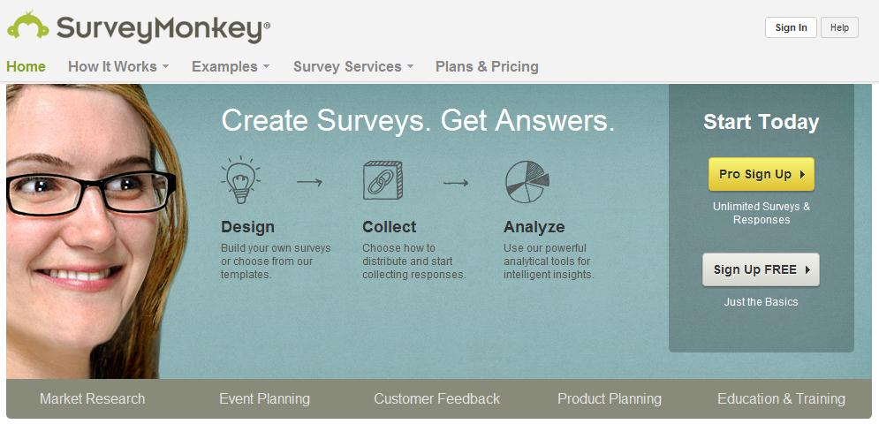
13 fig. SurveyMonkey web page.
SurveyMonkey is an easy-to-use tool for the creation of online surveys. Its primary strength is its intuitive Web interface, which makes it easy for even non-technical folks to create surveys and export-collected data.
SurveyMonkey was designed around the idea that someone with absolutely no programming skills should be able to use the program. Any new features are added only if they won’t add a layer of confusion. Based on customer feedback, was gradually improved certain areas of the website that give users the most trouble.
SurveyMonkey features a free and paid version. Both versions offer excellent surveying, data collection, and customization features. Before jumping into a Professional subscription, it suggests using the free account to get used to the interface and features. Once you are comfortable with how it works, upgrade to the Professional account for the additional features, if you need them.
A free limited account stores 10 questions per survey and 100 responses. Different survey templates and pre-set visual themes makes your survey look gorgeous and attractive. It offers data collection trough weblink, email, or Twitter. You can share your survey on Facebook, embed into a page or on your website or deploy via a website pop-up. All collected data you can monitor and analyze in real time. With a Professional account, you may create unlimited surveys with an unlimited number of questions. It has advanced features, like the ability to branch questions based on response and exporting to different formats, including HTML, CVS and SQL. SurveyMonkey also helps getting people to your surveys. You can create email lists with custom invitations. Again, the interface is easy to use and allows you to either add names and addresses by hand or import them from a text file. You can also track an individual’s identity through the survey. Also you get a lot of additional features, depending on the account type.
http://s3.amazonaws.com/SurveyMonkeyFiles/UserManual.pdf

4.2.LimeSurvey
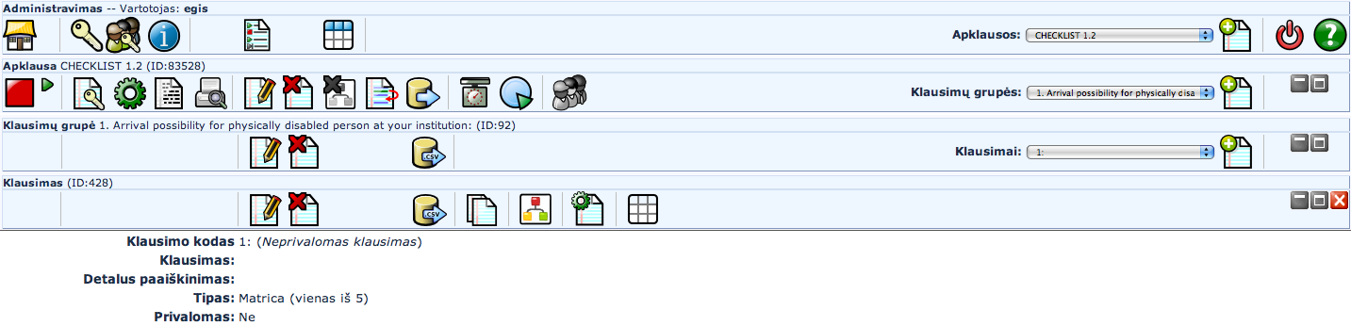
14 fig. LimeSurvey interface.
LimeSurvey (formerly phpSurveyor) is an open source online survey tool written in PHP, which allows users to create, administer, and analyze online surveys. It is important to note that LimeSurvey is not a desktop application that is installed on a personal computer, it is a web application that must be deployed on a server with PHP and MySQL capabilities (these are common web server technologies). It takes a lot of time to install and configure the software. But although the initial setup is somewhat technical, once the setup process is over, anybody can start using the software for setting up the survey. Because of this, LimeSurvey may not be an option for the individual. It would be a more likely scenario for organizations or enterprises to have a LimeSurvey installation on its server. For individuals a company LimeService offers LimeSurvey hosting for a small fee. This service is similar to web applications such as SurveyMonkey, the main difference being that LimeService's fees are based on the number of people that respond to the survey and not on the time that the survey is active for, like other similar services. LimeService offers up to 25 free responses per month, after which responses can be purchased in one of several packages.
LimeSurvey surveys are accessible to participants and administrators through a web browser. The survey software has a dashboard that you can use for a variety of purposes like monitoring the surveys, setting quotas, and displaying the results into a range of formats as well as local Excel spreadsheets.
The appearance of surveys is customizable through a built-in template editor or through HTML coding. This gives the survey administrator a great deal of control over how the survey interface will appear to participants. Even without modification, the standard templates are clear and intuitive. The same cannot necessarily be said about the administrator interface, which requires the administrator to drill down through layers of unlabeled icons. After some experience with the administration interface, however, it becomes quick and easy to create surveys, collect their results, and analyze the data.
LimeSurvey basically contains everything you need for doing nearly every survey with grace. It offers unlimited number of surveys at the same time, unlimited number of question in a survey, unlimited number of participants to a survey, more than 20 different question types (including essay types), survey tokens to prevent repeat participants, and branching surveys that present different questions based upon previous responses. LimeSurvey's feature set is so broad because it is used for many tasks, including tracking voting irregularities. Surveys can be public, or can be strictly controlled through the use of “once-only” tokens for each survey participant. Apart from all that, you get PDF automatically and also printed versions of the survey.

4.3. Google form/spreadsheet
Google forms/spreadsheet allows you to create quick, simple, and powerful submission forms and surveys. It’s a feature of Google Docs services. Google Docs is a free, Web-based office suite and data storage service offered by Google. It allows users to create and edit documents online while collaborating in real-time with other users.
To get started, you need to have or create Google account, then to log into Google Docs, push “Create” button and choose “Form” from drop down menu. Give your new form a name and start adding questions. 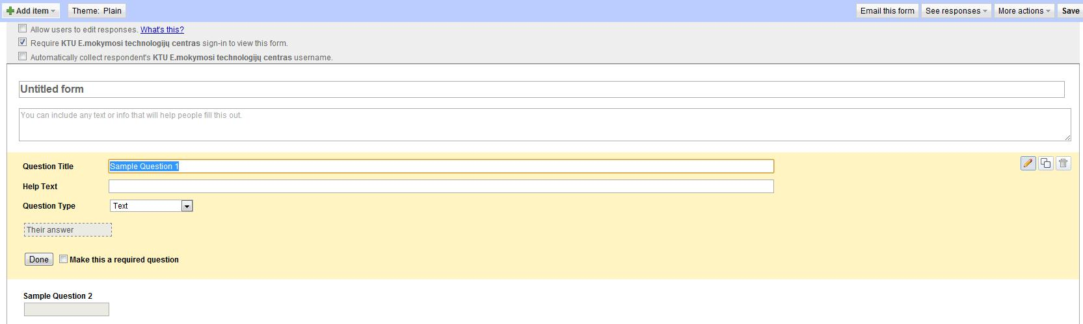
15 fig. Google spreadsheet interface
The number of questions in the survey is unlimited, and question types can be switched later:
- Text,
- Paragraph text,
- Multiple choice,
- Checkboxes,
- Choose from a list,
- Scale,
- Grid.
Every question can be required or free to answer. Google form interface is intuitive and user-friendly, so it takes just a few minutes to master.
Google forms features which separates it from others:
- Data goes directly into a Google spreadsheet, similar to Excel (that means you can take the results and publish them, use spreadsheet gadgets or charts with them, or export the results to use in Excel or another desktop spreadsheet program).
- Form/survey can be embedded directly in a web page on website (it generates the code to embed form into a Web page).
- Data can be exported in a variety of formats (.xls, .ods, .pdf, .csv, .txt, .html).
- Supports Email direct links to the survey from within Google docs (the public URL linking to the form).
- Supports email notifications to multiple users.
- Includes limited branch logic displaying different survey pages depending on earlier responses.
- Surveys can be customized with over 40 themes.
- Has attractive and functional display of results.
- Require users to be logged in (this can ensure one entry per user or simply let you know who submitted the data. Optional).
It looks far more professional than a lot of free survey tools out there. And the biggest advantage is that it works and stores everything in the cloud.

Learning unit 5. E-facilities for online marketing solutions
Modern society is becoming increasingly dependent on information presented in traditional and new mass media. It helps to know the outside world and enhance our experience. It regulates and controls social processes. In our era of information society news reaches us in lots of channels and you are taking the continuing flow of knowledge even if it is not very necessary. This stream is designed for everyone without age and gender because the main stream of knowledge flows through television, radio, newspapers, magazines and online sites.

5.1. E-bookstores
Currently, many areas of life are transferred to the electronic space. The book is no exception. Although there are still many libraries, some publications are available to take home to read, however, publications submitted electronically are becoming more and more popular. Both library and bookstores are moving to the Internet and evolving so-called e-book stores. People can buy books online and one of the biggest e-bookstore advantages is that - book prices are lower. One of the most popular e-bookshop in Lithuania is the “Pegasas bookstore” - http://www.pegasas.lt. There are more similar sites as http://www.knygininkas.lt, http://www.knyguklubas.lt, http://www.vetinfo.lt/16, http://www.patogupirkti.lt, and http://www.manoknyga.lt. Here you can find detailed information about books, it is possible to choose the most popular and best-selling books and also you can find other readers' feedbacks. The goods ordered from websites will be delivered directly to the location, because stores exist only in cyberspace. There are used books store online as well - http://www.sena.lt. It is possible to purchase older, used books at lower prices. This is the kind of book website where registered users can sell their books. All books are classified by price but it is also possible to perform search by title or author’s name.

5.2. E-banking
It is sufficient to use computer with an Internet connection and web browser to use the online banking services, no additional hardware or software is required. Internet banking is also cheaper than any bank branch and it offer to pay bills, review your bank statements and order other banking products such as payment cards, loans, deposits, etc. Often online banking can perform complex financial transactions such as currency speculation and variety of investment transactions. In addition you can pay for goods or services purchased in online stores by using your online banking services.

5.3. E-shops
Internet shopping is defined as a process in which the buyer purchases goods or services online in real time using the cyberspace. This shopping takes place without intermediaries saves time and you can get your ordered goods without even leaving the house http://pigu.lt
New information and communication technologies are integrated into all aspects of modern life, whether it is online banking or shopping or communication with your friends and colleagues.
So which kind of Information and communications technology are you using?

5.4. E-tickets
It is a need to use public transport to get from one point to another every single day. For many years in Lithuania passengers in public transport used paper tickets - monthly or single. These tickets are sold in kiosks or other distribution sites. Therefore, for some time in major cities of Lithuania electronic ticketing system was introduced. E- ticket - a multiple - entry card, which can be used unlimited amount of times. In addition, the new system allows us to supplement the ticket online, there is no need to go to the media distribution kiosk or other location.

5.6. Social services
Social services - means services provided to help a person (family), age, disability, social problems in whole or in part do not have, or lost skills or opportunities to self-care personal (family) life and in society.
The online social services aim is to enable a person to develop or enhance skills and capabilities to assure their needs, to maintain social contacts in public space, as well as helping to combat social exclusion.
These services can get different groups of people: older people and their families, persons with disabilities and their families, left without parental care, children at social risk children and their families, families at risk, children in foster family, other individuals and families.

Learning unit 6. E-commerce as a possibility for business introduction and implementation
E - commerce is intended for buying or selling products and services over electronic systems such as the internet and other computer networks. E-commerce draws on such technologies as electronic funds transfer, supply management, internet marketing support, inventory management systems, and automated data collection systems. In nowadays electronic commerce typically uses the www at least at one point in the transaction's life cycle, although it may encompass a wider range of technologies such as iPads, Smartphones and mobile devices, etc..
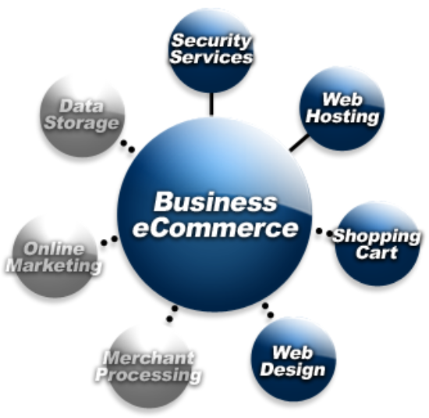
16 fig. E- commerce solutions (http://www.sunwebcare.com/servicesweb-development/e-commerce-solutions/)
E-commerce is generally thought of as the ability for a website to accept and process credit cards in exchange for goods or different online services. E-commerce is also sometimes thought of as conducting business over online. In the more traditional sense, e-commerce deals with both accepting and processing credit cards where e-commerce software lists prices for products or services, includes a shopping cart and the ability to accept personal information and credit card information:
- E - commerce is generally considered to be the sales aspect of e-business. It also consists of the exchange of data to facilitate the financing and payment aspects of business transactions.
E-commerce can be divided into:
- e-tailing or “virtual storefronts” on web sites with online catalogues, sometimes gathered into a “virtual mall”,
- the gathering and use of demographic data through web contacts using ICT possibilities,
- electronic data interchange, the business-to-business exchange of data,
- e-mail and fax and their use as media for reaching prospects and established customers (for example, with newsletters),
- business-to-business buying and selling,
- the security of business transactions.

Learning unit 7. E-marketing for small and medium enterprises
From creating a business plan, to a network strategy, lots of small and medium enterprises continue to fail and close their doors. Often, this happens because of bad management or not having an audience targeted marketing plan to actually bring revenue to the company. We going to walk through the basics of marketing that all entrepreneurs and business owners should master to hopefully reach the goals and growth needed for their business.

7.1. What is Marketing?
There are tons of definitions to the word marketing, and in the fast-moving world of business, it’s understandable that definitions rarely stay the same. But in short terms, marketing has been described as the process of interesting potential customers and clients in your products and/or services.
As a practice, it consists in coordination of four elements:
- identification, selection, and development of a product,
- determination of its price,
- selection of a distribution channel to reach the customer's place,
- development and implementation of a promotional strategy.
The marketing concept is a philosophy. It makes the customer, and the satisfaction of his or her needs, the focal point of all business activities. It is driven by senior managers, passionate about delighting their customers. It is founded on the belief that profitable sales and satisfactory returns on investment can only be achieved by identifying, anticipating and satisfying customer needs and desires.

7.2. Why Marketing is so important?
Are you starting a business, or are you already an entrepreneur? Either ways, if you are serious about building a brand and achieving success for your organization, you have to start marketing your business if you are not doing it yet. Marketing is a very important aspect in business since it contributes greatly to the success of the organization. Production and distribution depend largely on marketing. There are lots of benefits in having the right marketing strategy for the good product and not pushing more some products and disregard their wants and the value they can really bring to the customer. There are some reasons why marketing is important:
- Marketing promotes product awareness to the public as you cannot afford to just let people find out about your business themselves. You have to advertise, promote and educate the public about the goods of your business. This is why a company must invest in marketing so as not to miss the opportunity to be discovered and sell its products. It’s good to have a great product but if nobody knows about it, you will make no profits.
- Marketing helps boost product sales: if your company aims to increase the sales percentage and double the production, the marketing department must be able to come up with effective and strategic marketing plans. This is critical not only to generate sales, but also to build a brand and a strong reputation for a company.

7.3. Business Marketing Plan
The most effective way to grow and expand your business is by focusing on organic growth. And basically, you can increase organic growth in four different ways. They include:
- Acquiring more customers,
- Persuading each customer to buy more products,
- Persuading each customer to buy more expensive products or up selling each customer,
- Persuading each customer to buy more profitable products.
Sample Circular Marketing Structure
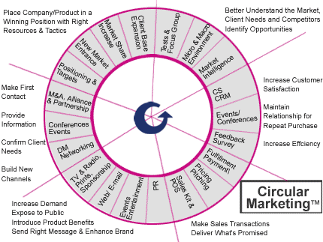
17 fig. (http://www.arumainc.com/circular.html)
To achieve all these goals, and bring your business to success, you need to develop a proper business marketing plan, and then gauge its performance for your business growth. Here are some points that your plan should have:
- What are your business marketing goals: this is simply what you want to achieve through your marketing plan. It can be sales, growth, reputation or something else.
- What is your target audience: it is important to have and know the target for you marketing campaign, this will not only identify the scope and range of your marketing but also prevent you for marketing your product to the wrong audience and therefore wasting your money and not getting the results that you have set for your business marketing.
- What business marketing system to use: internet has made business marketing a whole new concept, apart from the conventional advertisement systems in newspapers, magazines; internet or online marketing is the most used marketing system, since it is inexpensive when examining the ratio of cost to the reach of the target audience. In fact, companies can reach a wide audience for a small fraction of traditional advertising budgets. Internet marketing ties together the creative and technical aspects of the internet, including design, development, advertising, and sales; banner ads on specific websites, email marketing, and web 2.0 strategies like social and mobile applications.

7.4. Difference in traditional and network marketing
Traditional Business | Network Marketing Business
1. Investment  2. Responsibility  3. Effort  4. Time | 1. No Investment Required  2. Business growth reduces responsibilities  3. Business growth reduces time  4. Business growth reduces efforts

Famous Internet marketing strategies in the variety of solutions that offers the web, and depending on the marketing goals and target audience, these forms of marketing prevail:
- Search engine marketing: It is a form of Internet marketing that seeks to promote websites by increasing their visibility in search engine result pages through the use of, paid placement, contextual advertising, and paid inclusion.
- Affiliate marketing: where a third party advertises products or services on behalf of a retailer in return for an agreed commission for a sale or lead. This method has proved very popular due to its' “pay for performance” model which allows a large number of affiliates to be taken on, but only rewarding those which return results.
- Email marketing: It is a form of direct marketing which uses electronic mail as a means of communicating commercial or fund-raising messages to an audience. It involves sending email messages, adding advertisement in email messages.
- It is an Internet advertising model used on websites, where advertisers pay their host only when the ad is clicked.
One last important thing is to not forget to track your marketing efforts. You will be spending money and energy on your marketing so it’s worth the investment to make sure everything is working as planned. If not don’t be afraid to change your strategy and make some adjustments to your marketing plan.

Self assessment tests

Learning Unit 1
- Social Software is used in Enterprise 2.0 for:
  - supporting users to manage different information and solutions (+)
  - sharing vacation and parties photos (-)
  - organizing employees communication (+)
  - finding interesting people (-)

- Name types of social software, used in Enterprise 2.0:
  - corporate blogs (+)
  - e-mail clients, like Microsoft Outlook (-)
  - corporate wikis (+)
  - documents processing software, like Microsoft Office (-)
  - internal community platforms (+)

- Social software functions in Enterprise 2.0:
  - content or users search (+)
  - e-mail (-)
  - grouping content or users together (+)
  - authoring, including blogs and wikis (+)
  - website content management (-)
  - tagging (+)
  - content, based on profile (+)
  - social networking (+)
  - cloud computing (-)

- Starting online business, you have to identify 3 main areas/methods/models, name them: (open question)
  - technologies
  - development models
  - delivery methods

- 3 steps how to start online business (open question)
  - choose your focus, identify your area of expertise
  - create an online presence, build a content website, monetize your site
  - finance your endeavor, select online payment processing service

Learning Unit 2
- Select Web 2.0 tools for business management
  - Blogs (+)
  - Content Management Systems CMS (-)
  - Wiki (+)
  - Microsoft Office or other documents processing systems (-)
  - RSS (+)
  - Twitter (+)
  - Customer Relationship Management CRM (-)

- Select types of blogs:
  - Personal blogs (+)
  - Machinery blogs (-)
  - Corporate or organizational blogs (+)
  - Blogs by genre (+)
  - Instant messaging blogs (-)
  - Blogs by media type (+)
  - Blogs by device (+)
  - Reverse blog (+)

- Name blog features:
  - content is published in a chronological fashion (+)
  - readers can modify blog content (-)
  - content is updated regularly (+)
  - readers have possibility to leave comments (+)
  - users can upload their files for storing (-)
  - other blog authors can interact via trackbacks and pingbacks (+)
  - content could be syndicated via RSS feeds (+)

- Name Wiki features:
  - allows user to collaborate in forming the content (+)
  - allows users to leave comments (-)
  - allows users to modify wiki content (+)
  - content is published in a chronological fashion (-)

- Twitter features
  - broadcast your messages to your “followers” (+)
  - user has to follow his followers, if he wants them to get his messages (-)
  - message length is limited to 140 characters (+)
  - users can follow other users and their messages (+)
  - message length is limited to 256 characters (-)

Learning Unit 3
- What is Camtasia Studio?
  - Web-based meeting/classroom environment for web collaboration (-)
  - video-based screen capturing software program (+)
  - a free web based video service (-)

- Select Camtasia Studio use cases:
  - software tutorials for discipline-specific or lab software (+)
  - explanation of a process displayed in discipline-specific software (+)
  - video material storing and administration (-)
  - Web site tours (+)
  - narrated PowerPoint presentations (+)
  - professional video material editing (-)
  - narrated explanation of lecture notes, homework solutions or other materials (+)
  - web collaboration during material production (-)
  - video and audio podcasts production (+)

- What is Adobe Connect?
  - Web-based meeting/classroom environment for web collaboration (+)
  - video-based screen capturing software program (-)
  - a free web based video service (-)

- Select Adobe Connect use cases:
  - conduct web meetings (+)
  - professional video material editing (-)
  - share your screen during web meeting (+)
  - deliver online training in real time (+)
  - media library administration (-)
  - deliver online training on demand (+)
  - deliver online training offline (+)
  - purchasing material from web store (-)
  - facilitate webinars with interactive multimedia content (-)

- What is YouTube?
  - Web-based meeting/classroom environment for web collaboration (-)
  - video-based screen capturing software program (-)
  - a free web based video service (+)

Learning Unit 4
- Marketing research by target market consists of:
  - consumer marketing research (+)
  - qualitative marketing research (-)
  - business-to-business (B2B) marketing research (+)
  - quantitative marketing research (-)
- Marketing research by methodological approach consists of:
  - consumer marketing research (-)
  - qualitative marketing research (+)
  - business-to-business (B2B) marketing research (-)
  - quantitative marketing research (+)

- Select online survey services:
  - SurveyMonkey (+)
  - YouTube (-)
  - LimeSurvey (+)
  - SurveyDonkey (-)
  - Adobe Connect (-)
  - Google form/spreadsheet (+)
  - Adobe Survey (-)

Learning Unit 5
- Name e-facilities for online marketing solutions
  - e-bookstores (+)
  - e-banking (+)
  - e-food (-)
  - e-shops (+)
  - e-government (-)
  - e-libraries (+)
  - e-tickets (+)

Learning Unit 6
- E-commerce consists of:
  - virtual storefront (+)
  - business-to-business exchange of data (+)
  - product manufacture (-)
  - e-mail and fax use for reaching prospects and established customers (+)
  - business-to-business buying and selling (+)
  - security of business transactions (+)

Learning Unit 7
- Name main marketing elements:
  - identification, selection, and development of a product (+)
  - customer service (-)
  - product price determination (+)
  - selection of a distribution channel to reach the customer’s place (+)
  - company personnel selection (-)
  - development and implementation of a promotional strategy (+)

- Pick right statements about marketing:
  - marketing promotes product awareness to the public (+)
  - marketing reduces product attractiveness (-)
  - marketing helps boots product sales (+)
  - marketing reduces product sales (-)

- Pick right statements about network marketing business (in compare with traditional business)
  - No investment required (+)
  - Major investment required (-)
  - Business growth reduced responsibilities (+)
  - Business growth requires more responsibility (-)
  - Business growth reduced time (+)
  - Business growth takes more time (-)
  - Business growth reduced efforts (+)
  - Business growth takes more efforts (-)

- How can you increase organic growth?
  - acquiring more customers (+)
  - leaving only most profitable customers (-)
  - persuading each customer to buy more products (+)
  - restricting your product purchase to some customer groups (-)
  - persuading each customer to buy more expensive products or up selling each customer (+)
  - persuading each customer to buy more profitable products (+)

- Select main points of business marketing plan:
  - business marketing goals (+)
  - target audience (+)
  - promotion channels (-)
  - business marketing system selection (+)

